**COMSATS University, Islamabad**

**Assignment # 1**

**Author: Muhammad Mujtaba SP22-BSE-036 1A**

**Course: Calculus (MTH-101)**

**Instructor: Dr. Tayyaba Ehsan**

**Date: April 9, 2022**

**Question # 1**

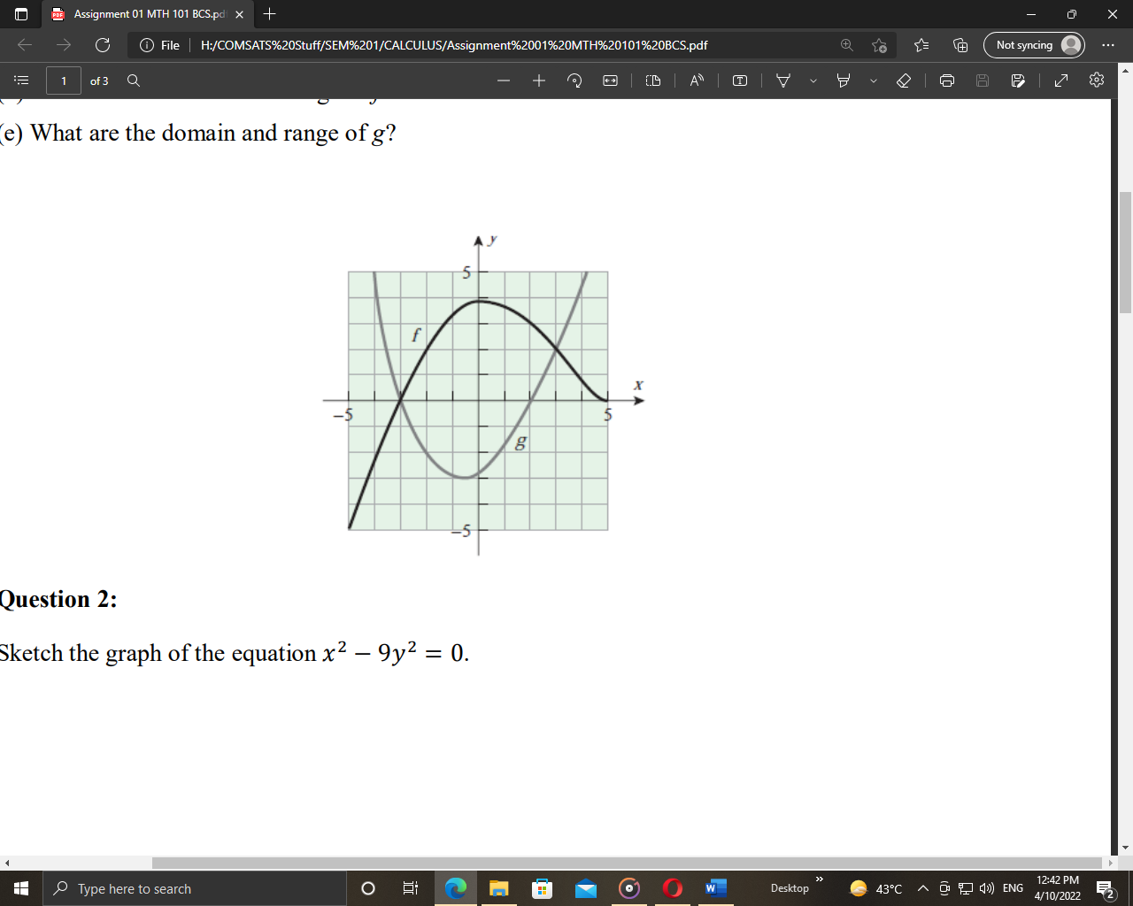Use the graphs of the functions f and g in the accompanying figure to solve the following problems.

**Solution**

1. Value of f(-2) is **2**. And the value of

g(3) is **2**. This is the value of y-axis for

each given x-axis value.

1. f(x) = g(x) for these values: **{-3, 3}**.
2. f(x) < 2 for values of x **other than** the values of x in range: **[-2, 3]**.
3. Domain of **f** is **[-5, 5]** and range of **f** is **[-5, 4]**.
4. Domain of **g** is **[-4, 4]** and range of **g** is **[-3, 5]**.

**Question # 2**

Sketch the graph of the equation $x^{2}-9y^{2}=0$

**Solution**

We simplify the equation first:

$$x^{2}=9y^{2}$$

$$y=±\sqrt{\frac{x^{2}}{9}}$$

$$y=-\sqrt{\frac{x^{2}}{9}} | y=\sqrt{\frac{x^{2}}{9}}$$

$$y=-\frac{x}{3} | y=\frac{x}{3}$$

|  |  |  |  |  |  |  |  |
| --- | --- | --- | --- | --- | --- | --- | --- |
| X | -3 | -2 | -1 | 0 | 1 | 2 | 3 |
| Y | 1 | 0.7 | 0.3 | 0 | -0.3 | -0.7 | -1 |

|  |  |  |  |  |  |  |  |
| --- | --- | --- | --- | --- | --- | --- | --- |
| X | -3 | -2 | -1 | 0 | 1 | 2 | 3 |
| Y | -1 | -0.7 | -0.3 | 0 | 0.3 | 0.7 | 1 |



**Question # 3**

Sketch the graph of the equation by translating, reflecting, compressing, and stretching the graph of 𝑦 appropriately, and then use the graphical utility to confirm your sketch is correct.

**Solution (part i)**

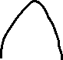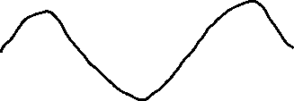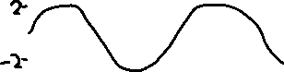

1. ½

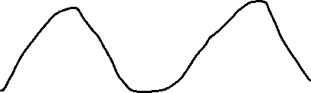

1. The functions that are **not** one-to-one are (according to the above numbering): **1, 2, 4, 5, 6, 7.**

**Solution (part ii)**

1. $f\left(x\right)=\frac{x^{3}}{x^{2}+1}$ find x if $f^{-1}\left(x\right)=2$

Since $f^{-1}\left(x\right)=2→f\left(2\right)=x→ \frac{2^{3}}{2^{2}+1}= \frac{8}{5}$

1. $f\left(x\right)=-\sqrt{3-2x}$ find $f^{-1}\left(x\right)$

$$y=-\sqrt{3-2x}→ y^{2}=3-2x→-2x=y^{2}-3→x={(y}^{2}-3)/(-2)$$

**Question # 4**

Find the domain and range of the following.

**Solution**

$y=-2+\sqrt{1-x}$

$1-x≥0$ and $1≥x$

So, domain: $\left(-∞,1\right]$

And range: $\left[-2,∞\right)$

$y=3^{2-x}+1$

Domain: $\left(-∞,∞\right)$

Range: $\left(1,∞\right)$

$y=\tan{(2x{-π)}}$

We know that $2x-pi≠90$

$$2x-pi=\frac{pi}{2} →2x=\frac{pi}{2}+pi →2x=3pi/2$$

$$x≠\frac{3pi}{4}$$

Domain: $\left[\frac{π_{n}}{2}+\frac{3pi}{4}\right]n_{i} (an integer)$

$y=x^{2/5}$

Domain: $\left(-∞,∞\right)$

Range: $\left(0,∞\right)$

$y=-1+\sqrt[3]{2-x}$

Domain: $\left(-∞,∞\right)$

Range: $\left(-∞,∞\right)$

**Question # 5**

Write the piecewise formula of the following.

**Solution**

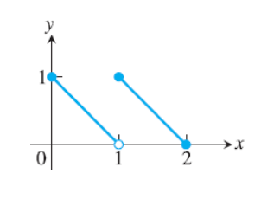

$f\left(x\right)=\left\{\begin{aligned}-x+1 0≤x≤1 \\ -x+2 1≤x≤2\end{aligned}\right.$

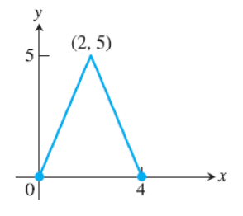

By applying formula: y = m(x – x`)

$$f\left(x\right)=\left\{\begin{aligned}\frac{5}{2}× 0<x<2 \\ \frac{-5}{2}x+10 2<x<4\end{aligned}\right.$$